SOLO PERFORMANCE

SCENE ONE: “I have a question”
SCENE TWO: “Pieces of me”
SCENE THREE: Hamlet.
SCENE FOUR: “It’s okay”
SCENE FIVE: Make Your Own Kind Of Music – Mama Cass Elliott.

SET DESIGN
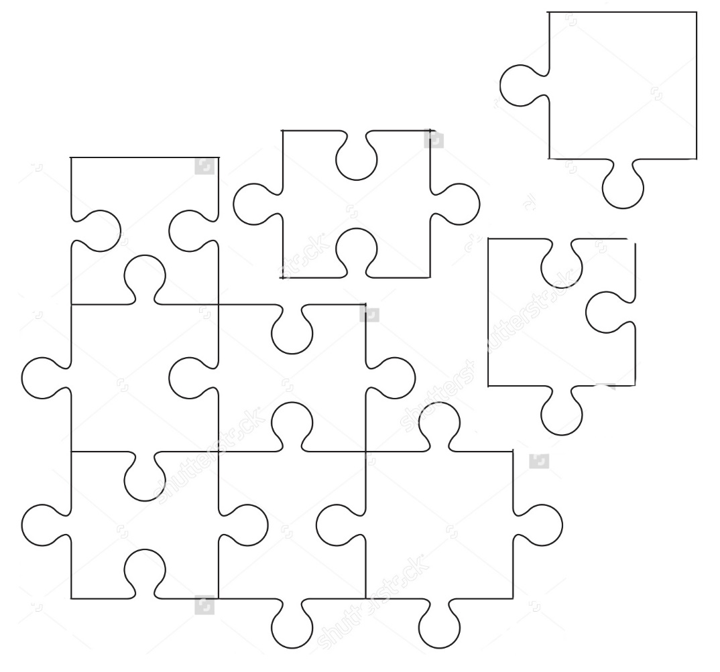

I HAVE A QUESTION

I have a question.

Why do we need to fit in?

All our lives we have an instinctive, impulsive need to fit in.
Why?
Who puts it in our minds that we have to be accepted?
That we have to be liked?
We all strive to be the same.
We all want to be popular and funny and clever.
We all want to be pretty and mirror some Barbie doll, Kim Kardashian type image.
Who was the one who said they were perfect?
Who was the one to say I’m not?

I’m so tired of expectations.
I’m tired of being told I have to be this. I have to be that.
Who says I have to be anything?
Limitation doesn’t exist.
The only limits that we have are the ones we give ourselves.
Every day I am tormented by my own mind.
Telling me I’m not doing this right.
I haven’t got this sorted, that sorted.
That I’ll be a failure if I don’t
Like I’m on some kind of timer.
A stop watch with time just running and running.
Panic always sets in when I realise I’m running out of time.
Yet it never occurs to me the question I need to be asking
Who started the stop watch?

Things only came into perspective when I heard something.
A string of words in a sentence.
It’s so simple, yet so meaningful.
“Worrying means you suffer twice.”
If what you’re worrying about is going to happen.
Why waste time and worry?
You can’t control it.
So don’t force yourself through the torment.

Anyone who knows me knows that I’m a big worrier.
I’m constantly stressing and living my life in fear of failure.
Fear of not meeting a deadline or disappointing someone.
I have no idea what it’s doing to my mental health.
Yet I know I won’t stop.
It’s written in my core.
I spent so much time worrying about this performance.
So I decided I’m done.
I’m so sick of worrying.

That quote was said by Newt Scamander.
Which I first heard when I saw Fantastic Beasts.
It was a Monday.
21st November 2016.
I have the cinema ticket.
In fact I have all the tickets to every film I’ve seen since Iron Man Three in 2013.

Those films mean a lot to me.
The characters.
Fictional people.

It’s funny how people like that never exist in our world.
I’m yet to find a wizard with a case full of magical creatures,
A mad man with a blue box or a man out of time.
But that’s obvious right?
Hogwarts isn’t real, neither is Galifrey or the Avengers.
Right?
Yet the point still stands.
I haven’t found a person who cares for animals more than themselves.
I haven’t found a person who’s got a sense of adventure and risk.
I haven’t found a good honest person with true values in life.
And that’s okay.
Because there are people out there like that.
They just don’t fit into the normal stereotype of what a person is supposed to be.

HAMLET SOLIOQUY

To die or to live?
Is it more reasonable to tolerate
Life’s problems, as unfair as they are,
Or to fight back and end our troubles
By committing suicide? When we die,
We no longer have to endure
The pain that is natural
For humans. Death is an end.
Truly to be wished for. Eternal sleep!
But we dream in our sleep. Yes there’s the catch.
For what kind of “dreams” do we have?
After we die?
This question keeps us from killing ourselves. That’s why
We put up with misery in our lives.
After all, who would endure the problems of life?
If he could find eternal rest.
Merely by using a knife?
Our fear of what happens after death,
That mysterious place from which.
No one has ever returned, confuses our choice
And makes us accept our misfortunes
Rather than risk even greater misfortunes.
This fear turns us into cowards…

